Alex Phillips

20172050

JavaScript project proposal

In this project I will be creating a jeopardy-style trivia game with questions about science. The categories will be laid out in rows and the questions will be columns with the difficult of each question increasing as you go down the columns. When the user selects a question, they will be presented with 4 options which they must pick from. Player score will increase or decrease depending on question position in the rows.

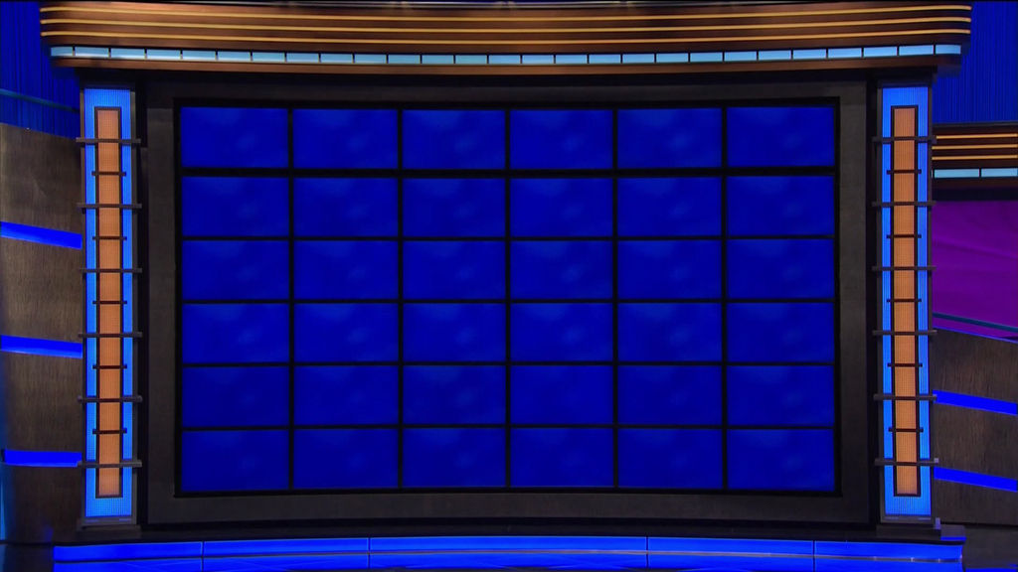

I’m not sure about sound sources yet

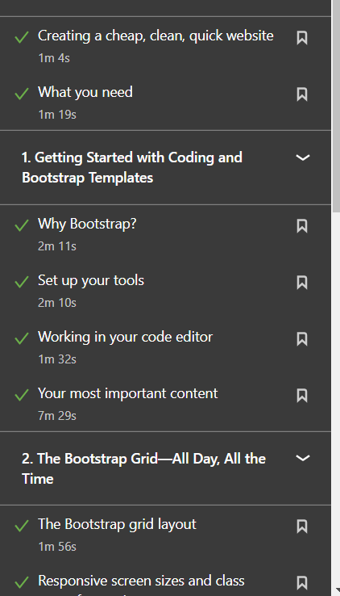



Git and GitHub

